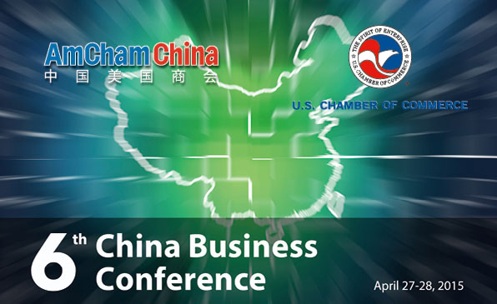

Monday, April 27, 2015
3:00 – 3:15 Introductory Remarks
Tami Overby, Senior Vice President for Asia, US Chamber of Commerce
James Zimmerman, Chairman, American Chamber of Commerce in China

3:15 – 4:15 Projecting the Relationship Through the U.S. Presidential Election and the 19th Party Congress
Ambassador Stapleton Roy, Founding Director and Distinguished Scholar, Kissinger Institute on China and the United States
Charles W. Freeman, International Principal, Forbes Tate
Moderator: Ambassador Karan Bhatia, Vice President and Senior Counsel, Global Government Affairs & Policy
4:15 – 5:00 A Conversation on China with Ambassador Robert Zoellick, former USTR and Deputy Secretary of State
Moderator: David Marchick, Managing Director, The Carlyle Group

5:15 – 6:00 The State of U.S.-China Economic Relations: Ambassador Michael Froman, United States Trade Representative
Moderator: TBD
6:00 – 7:30 Reception
Remarks: Kurt Campbell, Chairman and CEO, The Asia Group; Vice Chairman 100,000 Strong Foundation; Former Assistant Secretary of State for East Asia
Keynote Address: The Honorable Cui Tiankai, Ambassador to the United States of the People’s Republic of China (Invited)
Moderator: TBD

Tuesday, April 28, 2015

8:30 – 9:30 Projecting the Chinese Economy and Opportunities for U.S. Business to 2017
David Hoffman, Vice President and Managing Director, Conference Board China Center
Markus Rodlauer, Deputy Director for Asia Pacific, International Monetary Fund
Moderator: Dan Rosen, Partner and Co-Founder, Rhodium Group

9:30 – 10:30 Outlook & Operational Environment for Foreign Business in China: Sector Perspectives
AmCham China Business Climate Survey Presentation
Mark Duval, President, American Chamber of Commerce in China
European Perspectives
Joerg Wuttke, President, European Chamber of Commerce in China
American Perspectives
Jim Zimmerman, Chairman, AmCham China
Ken Jarrett, President, AmCham Shanghai
Moderator: William Zarit, Consultant; former Minister Counselor for Commercial Affairs, U.S. Embassy in Beijing

10:30 – 10:45 Coffee Break
10:45 – 11:45 U.S. and Chinese Roles in the Digital Economy
Emery Simon, Counselor, Business Software Alliance
Matt Roberts, Managing Director, U.S. Information Technology Office
Anne Stevenson-Yang, Director of Research, J Capital Research

Moderator: Randy Phillips, Managing Partner for Asia, James Mintz Group

11:45 – 12:45 Updates on Key Policy Issues in U.S. – China Economic Relations
Bilateral Investment Treaty Negotiations
Tim Stratford, Managing Partner, Beijing Office, Covington & Burling
Anti-Monopoly Law Enforcement, IPR and Industrial Policies
Les Ross, Managing Partner, Beijing Office, WilmerHale
Rule of Law
Eric Emerson, Partner, Steptoe & Johnson, Washington & Beijing Offices
Moderator: Ambassador Susan Schwab, Strategic Advisor, Mayer Brown LLP, and Professor, University of Maryland
12:45 – 2:00 Luncheon
Keynote Speaker: General Michael Hayden, Former Director of the Central Intelligence Agency
Moderator: Jim McGregor, Chairman, Greater China, APCO
Confirmed Participants:

Ambassador Karan Bhatia - Vice President and Senior Counsel, Global Government Affairs & Policy, The General Electric Company
Kurt Campbell - Chairman and CEO, The Asia Group; Former Assistant Secretary of State of East Asia
Mark Duval - President, American Chamber of Commerce in China
Eric Emerson - Partner, Steptoe & Johnson Washington & Beijing Offices
Charles W. Freeman - International Principal, Forbes Tate
Ambassador Michael Froman - United States Trade epresentative
General Michael V. Hayden – Former Director, Central Intelligence Agency
David Hoffman - Vice President and Managing Director, Conference Board China Center
Ken Jarrett - President, American Chamber of Commerce in Shanghai
David Marchick - Managing Director, The Carlyle Group
James McGregor - Chairman, Greater China, APCO
Randal Phillips - Managing Partner for Asia, James Mintz Group
Ambassador Stapleton Roy - Founding Director and Distinguished Scholar, Kissinger Institute on China and the United States
Matt Roberts - Managing Director, U.S. Information Technology Office
Markus Rodlauer - Deputy Director for Asia Pacific, International Monetary Fund
Daniel Rosen - Founding Partner, Rhodium Group
Lester Ross - Managing Partner, Beijing Office, WilmerHale
Ambassador Susan Schwab - Strategic Advisor, Mayer Brown LLP and Professor, University of Maryland
Emery Simon - Counselor, Business Software Alliance
Anne Stevenson-Yang - Director of Research, J Capital Research
Tim Stratford - Managing Partner, Beijing Office, Covington & Burling
Joerg Wuttke - President, European Union Chamber of Commerce in China
William Zarit - Senior Advisor to the Chairman of the Board and Head of Global Business Strategy, ENN Group
James Zimmerman - Managing Partner, Sheppard Mullin Beijing Office; Chairman, American Chamber of Commerce in China
Ambassador Robert Zoellick - Former USTR and Deputy Secretary of State

